Task Description:

MYSQL

Create a Table Empl to store employee details as shown below and write statement for

following queries based on table.

1.) Consider the Employee table and write SQL command to get the following.

A. Write a query to display EName and Sal of employees whose salary are greater than or equal to 2200?

B. Write a query to display details of employees who are not getting commission?

C. Write a query to display employee name and salary of those employees who don't have their salary in the range of 2500 to 4000?

D. Write a query to display the name, job title and salary of employees who don't have a manager?

E. Write a query to display the name of an employee whose name contains "A" as third alphabet?

F. Write a query to display the name of an employee whose name contains "T" as the last alphabet?

SQL QUERIES:

create table Employee (empno int primary key, ename varchar(50),

job varchar (50),mgr int, hiredate date, sal decimal (10,2), commn decimal (10,2), deptno int);

insert into Employee (empno,ename,job, mgr,hiredate,sal, commn, deptno ) values

(8369, 'SMITH', 'CLERK', 8902, '1990-12-18', 800.00, null, 20),

(8499, 'ANYA', 'SALESMAN', 8698, '1991-02-20', 1600.00, 300.00, 30),

(8521, 'SETH', 'SALESMAN', 8698, '1991-02-22', 1250.00, 500.00, 30),

(8566, 'MAHADEVAN', 'MANAGER', 8839, '1991-04-02', 2985.00, null, 20),

(8654, 'MOMIN', 'SALESMAN', 8698, '1991-09-28', 1250.00, 1400.00, 30),

(8698, 'BINA', 'MANAGER', 8839, '1991-05-01', 2850.00, null, 30),

(8882, 'SHIVANSH', 'MANAGER', 8839, '1991-06-09', 2450.00, null, 10),

(8888, 'SCOTT', 'ANALYST', 8566, '1990-12-09', 3000.00, null, 20),

(8839, 'AMIR', 'PRESIDENT', NULL, '1991-11-18', 5000.00, null, 10),

(8844, 'KULDEEP', 'SALESMAN', 8698, '1991-09-08', 1500.00, 0.00, 30);

select * from Employee;

A. Write a query to display EName and Sal of employees whose salary are greater than or equal to 2200?

select ename , sal from Employee where sal >= 1200;

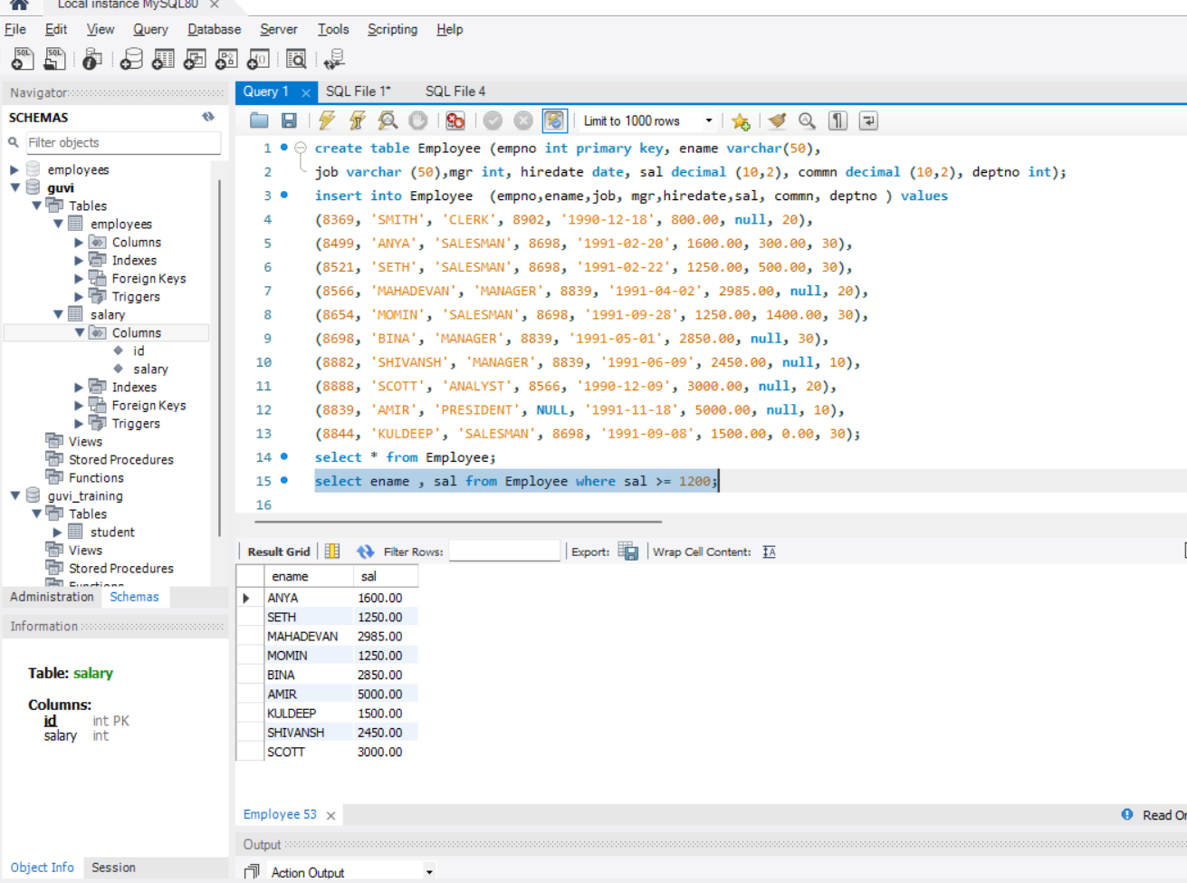

B. Write a query to display details of employees who are not getting commission?

SELECT * FROM Employee

WHERE commn is NULL and commn =0.00;

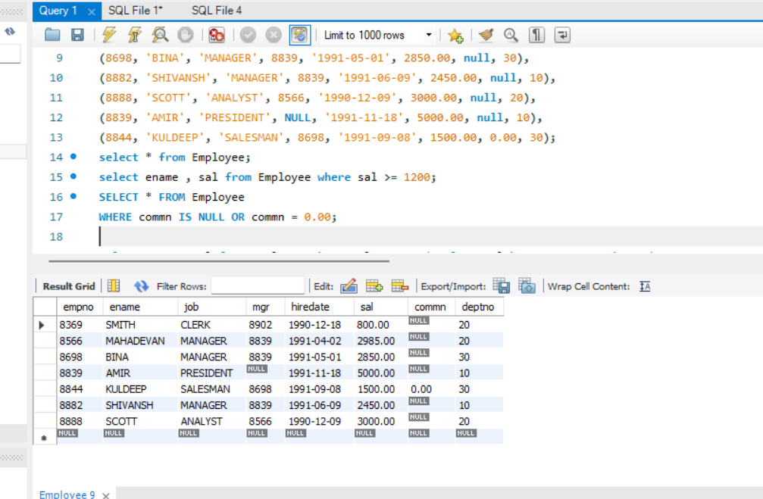

C. Write a query to display employee name and salary of those employees who don't have their salary in the range of 2500 to 4000?

select ename, sal from Employee where sal NOT IN ( select sal between 2500 and 4000);

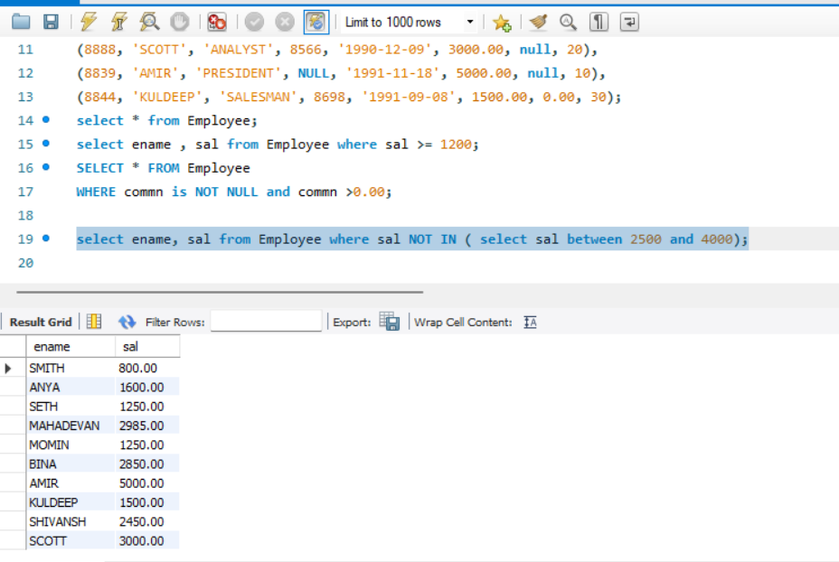

D. Write a query to display the name, job title and salary of employees who don't have a manager?

select ename, job, sal from Employee where mgr is NULL;

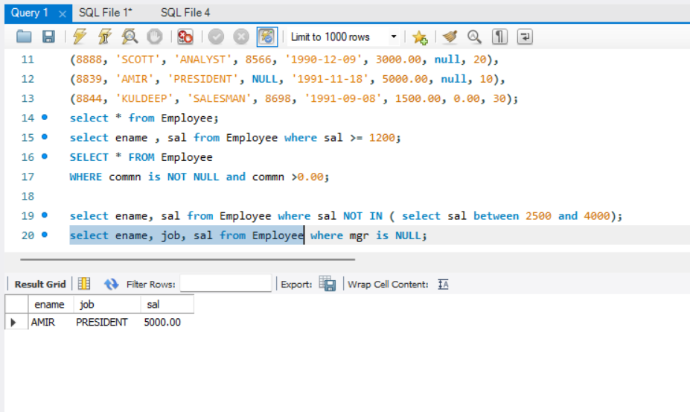

E. Write a query to display the name of an employee whose name contains "A" as third alphabet?

select ename from Employee where ename like '__A%';

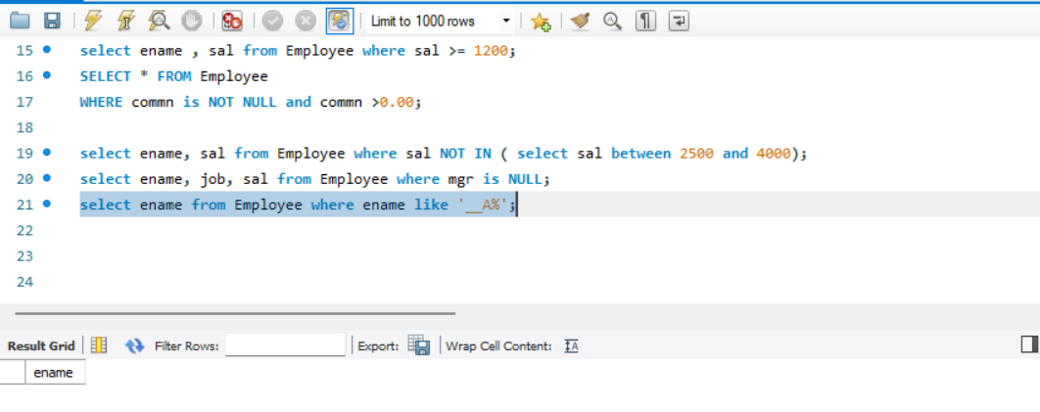

F. Write a query to display the name of an employee whose name contains "T" as the last alphabet?

SQL QUERIES:

select ename from Employee where ename like '%T';

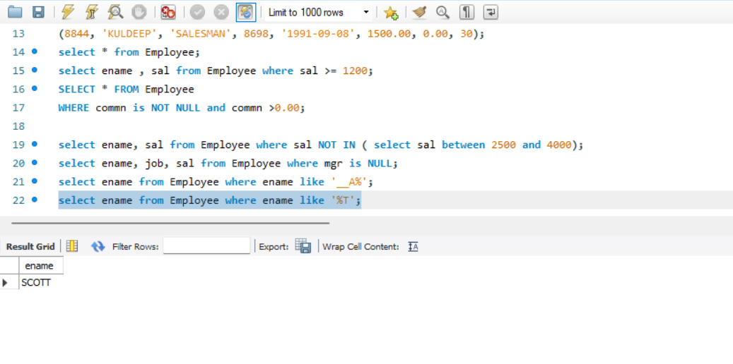

2.) Write a a program for JDBC to connectivity and insert the below data.

**package** javapackage;

**import** java.sql.Connection;

**import** java.sql.DriverManager;

**import** java.sql.SQLException;

**import** java.sql.Statement;

**public** **class** Task23EmployeeTable {

**public** **static** **void** main(String[] args) **throws** SQLException {

//1.create connection

Connection con = DriverManager.*getConnection*("jdbc:mysql://localhost:3306/guvi", "root", "HANA2@legend");

//2.create statement

Statement stmt = con.createStatement();

String s = "INSERT INTO EmployeeSalary (empcode, empname, empage, esalary) VALUES (101,'Jenny',25, 10000),(102,'Jacky',30, 20000), (103,'Joe',20, 40000), (104,'John',40, 80000), (105,'Shameer',25, 90000)";

//3.execute statement

stmt.execute(s);

//4.close connection

con.close();

System.***out***.println("Query executed successfully");

//

}

}

